**NWCSI/Alta Vista August Event 2010**

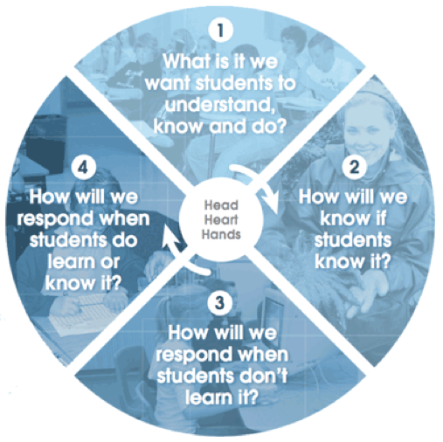**Centering our Practice Around Four Essential Questions**

**Part 1 – 4 essential questions for teachers**

1. **What do I want my students to learn?**
2. **How will I know if they learn it?**
3. **What will I do if some students don’t learn it?**
4. **What will I do if some students already know it or learn it quickly?**

**Part 2 – 4 essential questions for students**

1. **What do I need to learn?**
2. **How will I know if I learn it?**
3. **What will I do if I have difficulty learning it?**
4. **What can I do if I already know it or learn it quickly?**

**Part 3 – 4 essential questions for our professional community**

1. **What do we want our students to understand, know and be able to do?**
2. **How will we know if our students learn it?**
3. **How will we respond when our students don’t learn?**
4. **How will we respond when our students already know it or learn quickly?**

**Part 4 – 4 essential questions for our professional development**

1. **What do I/we need to learn?**
2. **How will I/we know if I/we learn it?**
3. **How will I/we respond when I/we don’t learn?**
4. **What are the next steps in my/our professional learning?**

**How can we make this a durable practice in our schools?**

When: August 17, 2010; 9:00 -2:00

Where: Mount Vernon Christian High School

Cost: $20 per participant Lunch will be provided

Contact: Elaine Brouwer - [avcelaine@comcast.net](mailto:avcelaine@comcast.net)

**Washington State Clock Hours available**