**Becoming Students of Our Students’ Work - Together**

**NWCSI August Event 2012**

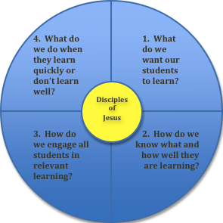

**“Students’ work is the text we read in order to understand our own work. It is where our moves as educators and their impact on students are most traceable.”**

“One good way for us to educate ourselves is to pause periodically . . . to become deliberate students of our students. . . . Instead of pressing for student work flow . . . judging quickly the value of the flow’s direction, we must on a regular basis suspend flow, capture images of the work interrupted, study the images calmly and deliberately, and explore together what they may mean.”

*The Power of Protocols: an educator’s guide to better practice* p3

School teams across the region are invited to come together as a larger professional learning community to explore ways to become deliberate students of our students’ work. The day will be organized around two essential questions:

**What can we learn by looking carefully at student work?**

**How can we use what we learn?**

Grade level/discipline facilitators will lead small groups in examining student work that they have collected from their own classrooms. School teams may also bring work samples from their classrooms. Resources provided will include a variety of protocols for examining student work. Time will be provided for school teams to reflect on what they learned.

When: August 23, 2012; Registration & coffee at 8:30, workshop - 9:00-2:00

Where: Mount Vernon Christian High School

Cost: $40 per participant; continental breakfast and lunch provided

Clock Hours: 5 WA State Clock Hours available

RSVP: Elaine Brouwer - [**avcelaine@comcast.net**](mailto:avcelaine@comcast.net)

The purpose of the August Event is to stimulate and facilitate a cross-Region discussion of how to fulfill our mission as Christian schools. While a special invitation is extended to administrators and teachers new to our Regional schools, we encourage schools to send a school team so they can carry the conversation back to their learning communities.